ID no. Press Release MEIKO Training Centre 2015, modified:
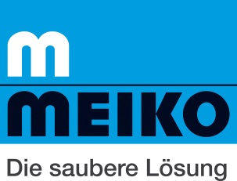

Meiko expands its worldwide service strategy

Meiko – the mechanical engineering firm based in southern Germany – has taken the next step in the evolution of its service strategy by opening a new training centre in Dubai, giving it a unique selling point in the kitchen equipment industry for the Arab market. Hans-Dieter Breideband, senior manager and Head of Global Service, explains why the company made the move: "Thinking globally and acting locally is the only sensible path for a global company to take. At the end of the day we are making a promise to our customers every time we deliver a machine – a promise that we can maintain the same levels of after-sales service performance and quality standards all over the world!"

In total, the manufacturer of commercial dishwashing, cleaning and disinfection technology now employs more than 600 service staff worldwide, and it already has training centres in Nashville, Slough, Santiago de Chile, Offenburg and Zhongshan. Meiko's dealer and service partners offer a further 4,500 authorised service technicians worldwide. For the past five years, the company has been running an authorisation programme which has proved to be a great success and which, according to Breideband, "is unique in the industry". Ongoing training and authorisation initiatives – including entry-level training, courses on individual product groups and train-the-trainer seminars – provide the best means of getting information across about new products, innovations and complex technical issues. And the permit to work as an authorised technician is only renewed for those people who pass the online test.

Hans-Dieter Breideband thinks that the future of the industry will see even more machines in action than today: "Meiko has read the signs correctly and configured its product portfolio so that customers don't just get something that cleans, washes and disinfects, but rather a machine that comes with a package of after-sales services that offer genuine added value." Breideband cites examples such as remote diagnostic services and tools for analysing and enhancing the performance of Meiko machines.

Caption:
Hans-Dieter Breideband, Head of Global Service

Press contact:
MEIKO Maschinenbau GmbH & Co. KG
Regine Oehler
Press and PR
oer@meiko.de
+49 +49 0 781 2031204

